USER MANUAL
user's manual

Spectral measurement software
Software model: FLAVOR
Release version number: FLAV.S.01

Table of contents
1 Software introduction 3
2 software download 4
3 Interface introduction 6
4 Detection panel 7
5 Device Panel 17
6 Spectral windows 22
7 Spectral Recording 26
8 Contact Us 29

Software introduction

Software Description
FLAVOR is a spectrum measurement and analysis software developed by SIMTRUM PTE LTD which is used for the setting and operation of SIMTRUM's optical fiber spectrometers, Raman spectrometers, lasers and other equipment. The interface of FLAVOR is simple and clear, and has the following features:
- Control multiple devices at the same time, can set parameters for each device separately, and carry out graphics and data operations.
- Bind the connected devices together. For example, combine and measure a spectrometer and a laser.

Software version
this FLAVOR software is V1.5 , which is the latest version. SIMTRUM will continue to upgrade F LAVOR to bring users a better operating experience.
Users can contact the technical support department of SIMTRUM to obtain software upgrade services through the following methods.

Manual version
this FLAVOR software instruction manual is S.01 . This version introduces how to install the software, control the spectrometer of SIMTRUM through the software, and obtain the measurement data.
If the user needs to use the software to control the Handheld Raman or other spectral modules, please contact the technical support department of SIMTRUM at info@simtrum.com to obtain the relevant operating instructions.

software download

software acquisition
There are two ways for users to obtain F LAVOR software:
- driver and the F LAVOR installation U disk are included in the product package of SIMTRUM , which can be inserted into the computer for direct installation.
driver
F LAVOR software | 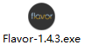
Note: The actual installed version number may be different from the icon shown above.

Software Installation
Step 1: Install the driver, follow the steps below:
- Click to open DRIVER , the driver will run automatically to complete the installation, as shown in Figure 2.1 .
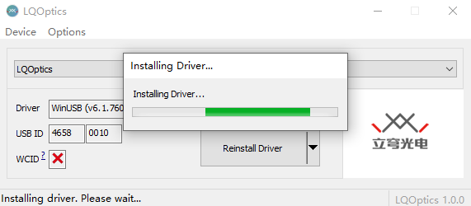
Figure 2.1

Step 2 : Install FLAVOR software, follow the steps below:
- Click FLAVOR to start the software installation program, then pop up the running dynamic diagram, and complete the installation with one click. As shown in Figure 2.2 .

Figure 2.2

- After the installation is complete, the F LAVOR shortcut will be automatically generated on the desktop, and the F LAVOR software interface will be directly entered. As shown in Figure 2.3 .
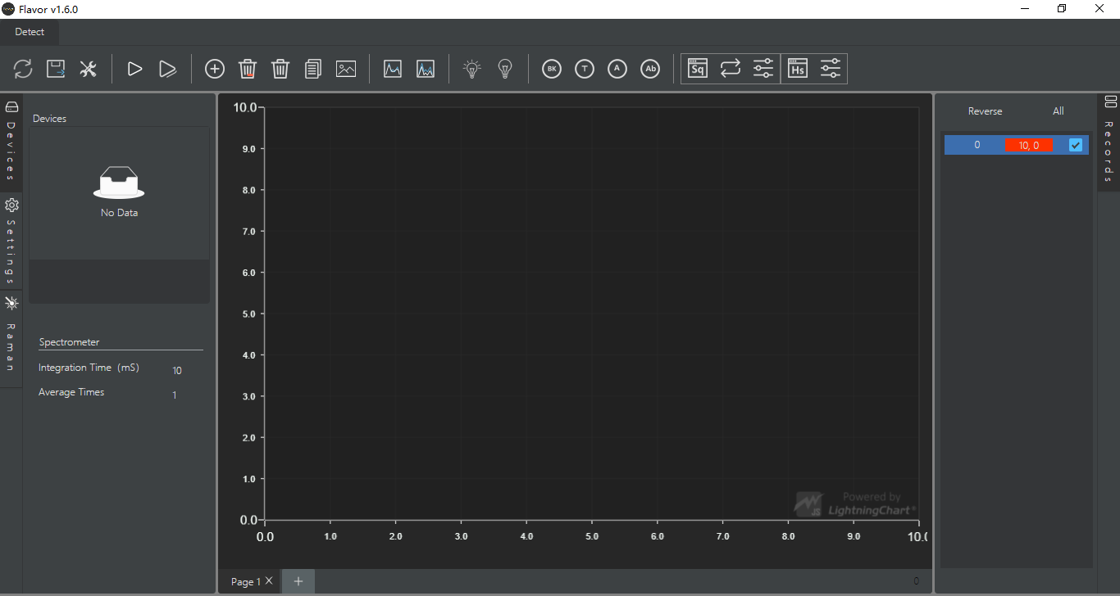
Figure 2.3

Interface introduction

interface structure
F LAVOR is simple and the operation buttons are clear at a glance.
F LAVOR interface is divided into four modules, as shown in Figure 3.1 below, which are 1 detection panel, 2 equipment panel, 3 spectrum window, and 4 spectrum recording.
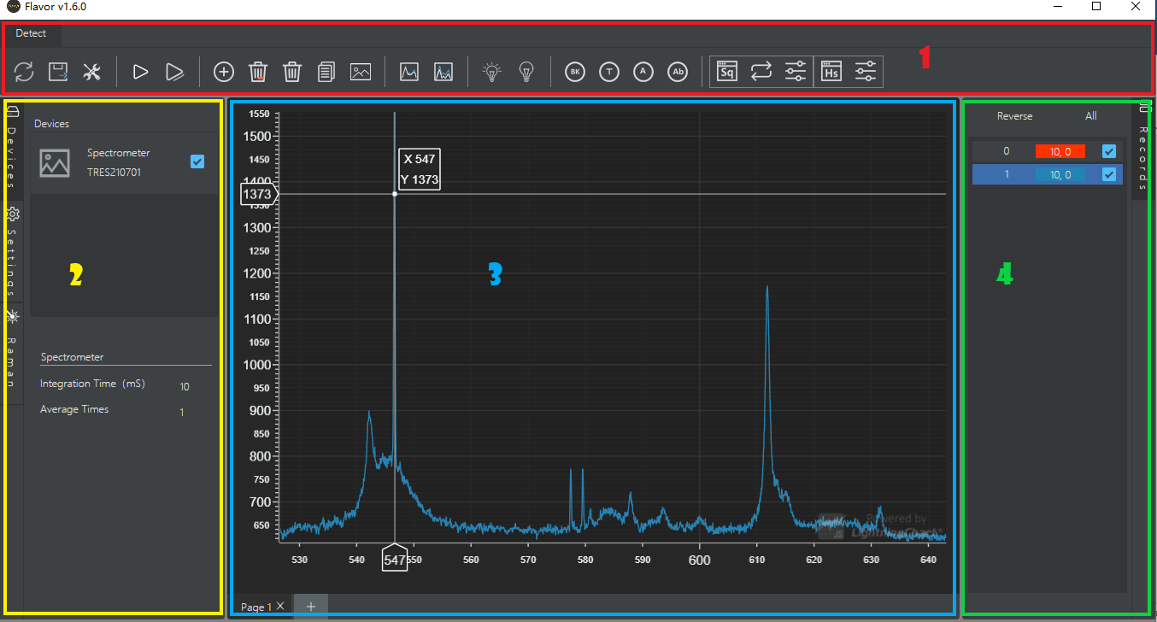
Figure 3.1 Interface structure

Module Introduction
1 detection panel | Function menu and operation buttons
2 Device panel | Device list and parameter settings
3 Spectral window | Spectral curve display and spectral window management
4 Spectral recording | Spectral curve selection and naming

detection panel

Inspection panel structure
The detection panel consists of the detection menu and the function buttons under the menu.
The current F LAVOR detection menu is "detection", and the lower part is divided into five detection modules, which are composed of different function buttons, as shown in Figure 4.1 .
Figure 4.1
When the mouse is placed on any button, the function name of the button appears below, as shown in Figure 4.2 .

Figure 4.2

Detection module structure
1 device file | 
2 Detection control | 
3 Spectral processing | 
4 Detection mode | 
5 Extended detection | 

device file
Manage device connections and export spectral data.
1 Refresh the device |  | After connecting or disconnecting a device, tap Refresh to update the list of connected devices.
2 export file |  | All spectral entry data displayed on the current page of the export spectrum window, or checked in the spectral record, are identified by the automatically generated serial number in the spectral record or the user-defined record name, press ( x ₁ ,y ₁ , x ₂ ,y ₂ …x _{n} ,y _{n} ) format, save as .t xt file.

Detection control
Execute the detection command and acquire the desired spectral curve.
1 single test |  | Click the button to perform an instant spectral detection. The current page of the spectrum window displays the latest spectrum curve.
2 continuous detection |  | Click the button to perform continuous spectral detection. Click again to end the current spectrum collection command. The current page of the spectrum window displays the latest spectrum curve.  When the button is selected, it is displayed in blue.
3 Increase the spectrum |  | Add the latest spectral curve acquired by the current detection device to the current page of the spectral window. A corresponding spectral entry is added to the spectral record at the same time.
4 delete current spectrum |  | Deletes the highlighted spectral entry in the current spectral record. The corresponding spectral curve on the spectrum page is deleted at the same time.
4 delete spectrum |  | Deletes all checked spectral entries in the current spectral record. The corresponding spectral curve on the Spectrum page is also deleted.
7 copy spectrum |  | The spectrum curve data displayed on the current page of the spectrum window or checked in the current spectrum record is identified by the name displayed in the spectrum record entry, in (x,y ₁ ,y ₂ ,…y _{n} ) format, Copy to facilitate pasting of data.
8 save Picture |  | Export the current page of the spectrum window, save as a png file.

Spectral processing
Perform wavelet smoothing or defluorescence processing on spectral curves.
When the button is selected, it is displayed in blue.
1 wavelength smoothing |  | Click the button to perform wavelength smoothing on a highlighted spectral curve in the current spectral record. Click again to restore the original spectral curve.  Highlight the selected spectrum record “0” spectrum acquisition entry, click the button, that is, set the spectrum acquisition to wavelength smooth spectrum acquisition. Click again to cancel the wavelet smoothing setting.
2 Defluorescence |  | Click the button to perform defluorescence processing on the highlighted selected spectral curve in the current spectral record. Click again to restore the original spectral curve.  Highlight the selected spectrum record "0" spectrum acquisition entry, click the button, that is, set the acquisition spectrum to defluorescence acquisition spectrum. Click again to cancel the defluorescence spectrum setting.

Detection mode
Perform spectral detection of transmittance, absorbance, and absorbance.
Except for the buttons for setting the light source spectrum and setting the background spectrum, other buttons are displayed in blue when they are selected.
1 Set the light source spectrum |  | Perform single detection or continuous detection, after acquiring the light source spectrum, click the button to set the current spectral data as the light source spectrum, and automatically save it to the background.
2 Set the background spectrum |  | Perform single detection or continuous detection, after acquiring the background spectrum, click the button to set the current spectrum data as the background spectrum, and automatically save it to the background.
3 Subtract the background |  | Click the button to perform background subtraction processing on the highlighted selected spectral curve in the current spectral record. Click again to restore the original spectral curve.  Highlight the selected spectrum record "0" spectrum acquisition entry, click the button, that is, set the acquisition spectrum to subtract the background acquisition spectrum. Click again to cancel the background subtraction setting.  Note: Before executing the background subtraction function, you need to set the background spectrum.
3 Transmission/Reflection Measurement |  | Click the button to display the transmittance/reflectance curve of the highlighted selected spectral curve in the current spectral record. Click again to restore the original spectral curve.  Highlight the selected spectrum record “0” spectrum entry, and click the button to set the spectrum to transmittance/reflection display mode. Click again to cancel the transmission/reflection spectrum setting.  NOTE: Before performing transmission/reflection detection, the light source spectrum and background spectrum must be set.
4 Absorbance measurement |  | Click the button to display the absorbance curve of a highlighted spectral curve in the current spectral record. Click again to restore the original spectral curve.  Highlight the selected spectrum record "0" spectrum entry, click the button, that is, set the spectrum to absorbance display mode. Click again to cancel the absorbance spectrum setting.  NOTE: Before performing absorbance detection, the light source spectrum and background spectrum must be set.
4 Absorbance measurement |  | Click the button to display the absorbance curve of a highlighted spectral curve in the current spectral record. Click again to restore the original spectral curve.  Highlight the selected spectrum record "0" spectrum entry, click the button, that is, set the spectrum to absorbance display mode. Click again to cancel the absorbance spectrum setting.  NOTE: Before performing absorbance detection, the light source spectrum and background spectrum must be set.

Extended detection
Perform spectral detection for sequential and high-speed acquisition.
1-1 Timing Settings |   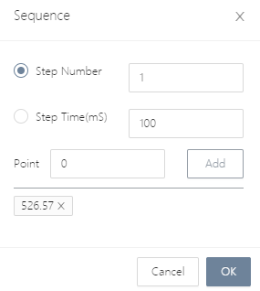 | Click the button (yellow box button in the upper left image) to open the " Sequence " timing setting window (lower left image).  Enter the time series window, enter the " Step Number " interval times, and the " Step Time " interval time parameter in turn; add the " Point " observation point, the default value is the starting band value (in this example, 5 26.57 ), you can enter or select Observation point, click "Add", the system will automatically give the actual observation point closest to the value and add it to the lower window. Click the "X" symbol to the right of the observation point to delete the observation point.  After parameter setting is complete, click " OK " to confirm. The Spectrum window opens a new Spectrum page named "S q "+"Serial Number" as the time series detection page.  Note: Subsequent timing detection will be displayed in the timing detection page window.
1 -2 Timing detection | 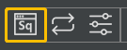 | Click the button to perform time-series detection, and the current spectrum page displays the spectrum moving graph indented continuously to the left. Click again to end the current timing detection.  Spectral record entry names are automatically matched to different observation point band values.  When the button is selected, it is displayed in blue.
1-3 Refresh Timing | 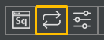 | Click the button to re-execute the current timing test.  Note: The refresh function can be executed only during the spectrum collection process of the time series detection.
2 -1 High Speed Acquisition Settings |   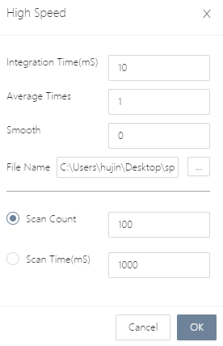 | Click the button ( yellow box button in the upper left image) to open the "High Speed " high-speed acquisition setting window (lower left image).  Enter the high-speed acquisition window, you can modify the default " Integration Time " integration time, " Average Time " average times, set the " Smooth " smoothness, and modify the file save address in the "File Name " option box. Modify the default "S can Count " scan times and "S can Time " scan time.  After parameter setting is complete, click " OK " to confirm.
2-2 high - speed acquisition |  | Click the button, and the spectrum window will open a new spectrum page named "Hs" + "serial number" as the current detection page. Within the set time, perform high-speed acquisition and detection, automatically generate spectral curves, and use the spectral acquisition time point as the name of the y value, in the format of ( x ₁ , y ₁ , y ₂ ... y _{n} ), synchronously export the spectral record file to the specified address.  Spectral record entry names are automatically displayed from "0" to "n- 1 ", a total of n entries. (n is the set number of scans)

Device panel

Device panel structure
The device panel includes a menu on the left and a control area on the right.
The menus are " Devices " device list, " Settings " parameter setting and " Raman " Raman module, placed on the left. The current module is displayed in dark color.
Open Flavor , the device list of " Devices " is displayed by default , and the control interface of the device list is displayed in the control area on the right.
The " Devices " device list is divided into 2 control modules, consisting of different function buttons and parameter settings, 1 device selection, 2 spectrometer settings, as shown in Figure 5.1 .
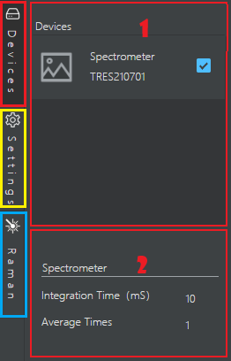
Figure 5.1
Click " Devices ", the control area on the right side of the device panel will be automatically hidden; click again to restore the display.
The " Settings " parameter setting is divided into 2 control modules, which are composed of different function buttons and parameter settings, including 1 default parameter and 2 refrigeration control, as shown in Figure 5.2 .
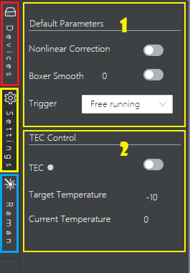
Figure 5.2
Click " Settings " , the control area on the right side of the device panel will be automatically hidden; click again to restore the display.
" Raman " Raman module, parameter setting for Raman. As shown in Figure 5.3 .
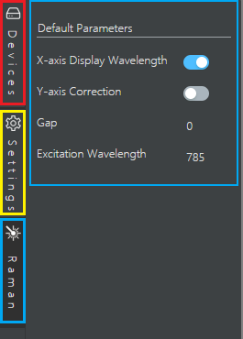
Figure 5.3
Click " Raman ", the control area on the right side of the device panel will be automatically hidden; click again to restore the display.
Note: For the operation and use instructions of the Raman module, there are other supporting instructions, which are not introduced in this version.

Device Selection
Spectrometer selection.
1 Device Information | 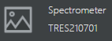 | Displays the name and serial number of the connected device.
2 equipment selection |  | Select the current working device to perform subsequent inspection tasks.

Spectrometer settings
Spectrometer parameter settings, including " Integration Time " integration time and " Average Times " averaging times settings.
Place the mouse on the value to display the input box, click to set the parameters; click any area outside the box again to take effect, as shown in Figure 5.4 .
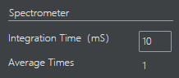
Figure 5.4

Default parameter settings
Click " Settings " on the left menu of the device panel to set detection parameters.
1 Nonlinear correction |  | Click the switch button to enable or disable the nonlinear correction function.
2 Boxer smoothing _ |  | Place the mouse on the value to display the input box, click to set the parameters; click any area outside the box again to take effect.  Click the switch button to enable or disable the Boxer smoothing function.
3 External trigger mode | 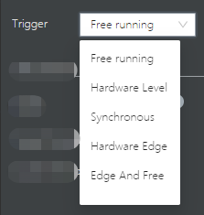 | Pull down to select external trigger mode, there are 5 types of modes to choose from.

Cooling control settings
Before using the cooled spectrometer, make the cooling control settings.
1 Cooling switch |  | Click the switch button to activate the cooling function.  Note: The cooling is successful, and the white dots are displayed in green.
2 target temperature | 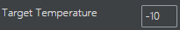 | Place the mouse on the value of "T arget Temperature ", the input box will be displayed, click to set the parameters; click any area outside the box again to take effect.
3 Current Temperature |  | Dynamically display the current cooling temperature.

Spectral window

Spectral window structure
The Spectrum window includes the Spectrum Curve area and the Spectrum Page bar at the bottom.
The spectral curve area displays the X and Y axes and the detected spectral curve.
The spectrum page bar displays all spectrum pages, click to switch.
Figure 6.1 .
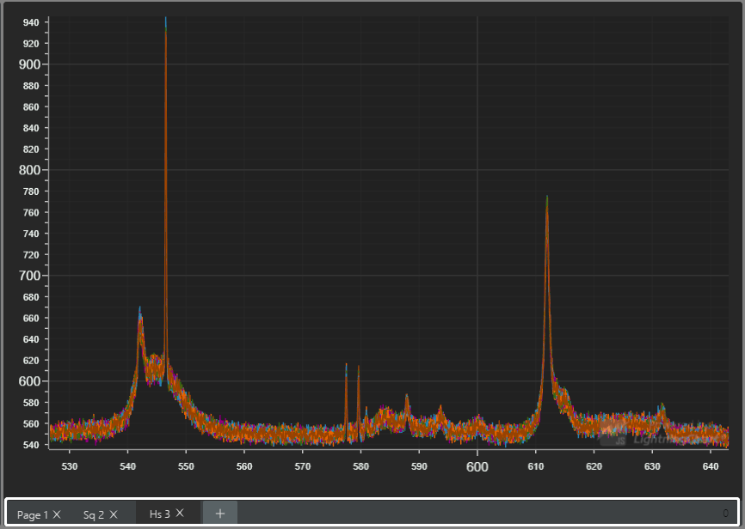
Figure 6.1

Spectral curve
Display spectral curves and acquire spectral characteristic data.
Combined with the spectral recording window, the composition and operation of the spectral curve area are introduced, as shown in Figure 6.2 .
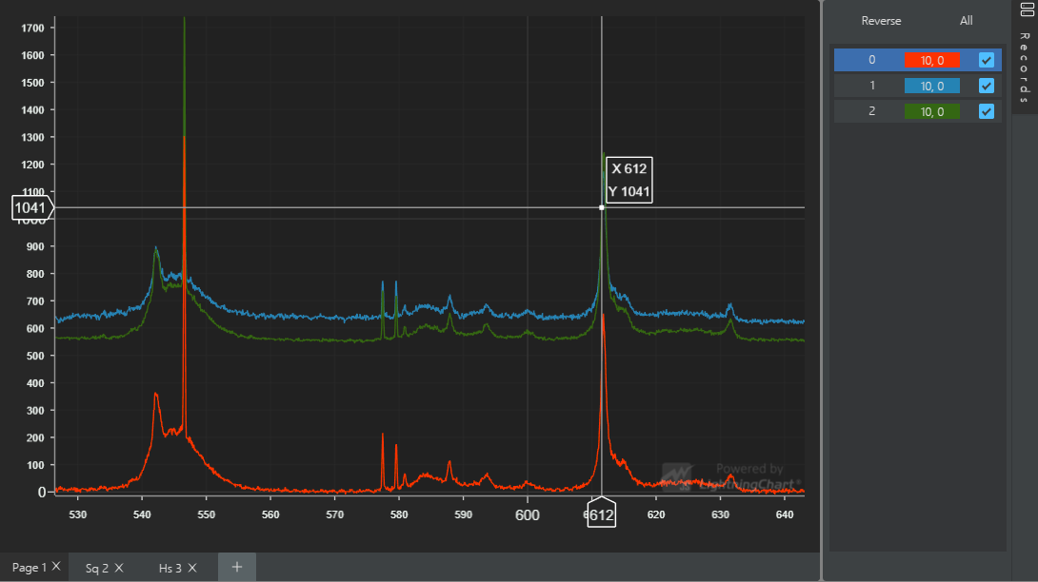
Figure 6.2

1 Spectral curve | 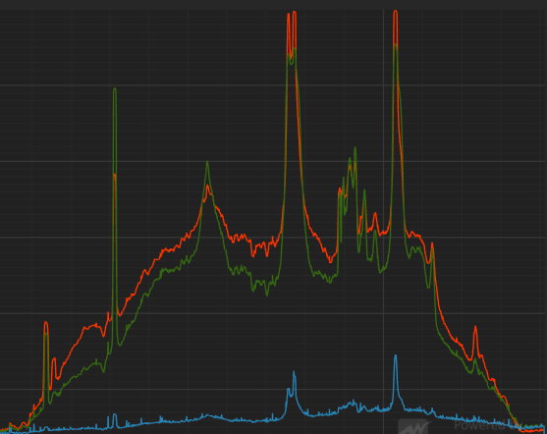 | Displays the selected spectral curve in the spectral record, and the color of the curve is the same as the color of the entry defined in the spectral record.  Note: In the spectrum record list, the first entry with the serial number "0" is the current working spectrum, corresponding to the latest spectrum in the acquisition state of the spectrum window.
2 Positioning cross axis | 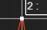 | When the mouse is placed in the spectral curve area, a white cross axis will automatically appear, and the intersection point of the axis is a curve point closest to the current mouse position.  When there is no spectral curve, the cross axis is a straight line parallel to the Y axis, which only locates the X value of the current mouse position.
3 X axis | 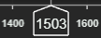 | Wavelength, in nm ; the wavelength data in the box line is the X-axis rounded value of the cross point of the cross axis on the graph.
4 Y- axis | 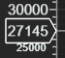 | In normal detection mode, the Y-axis is displayed as counts value data.  In transmittance/reflection and absorbance detection modes, the Y-axis is the percentage data.  In absorbance detection mode, the Y-axis is the Abs value .  Y- axis data in the frame line is the Y-axis rounded value of the cross point on the curve.
5 X/ Y value of the curve | 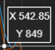 | Appears at the same time as the positioning cross axis, and displays the X / Y axis value of the curve where the positioning cross axis is located, in ( x,y) format.
6Curve move | right mouse button drag | Click and hold the right mouse button to drag the spectral curve arbitrarily in the curve area.
7 Curve scaling | Mouse wheel sliding | Slide the mouse up to zoom in on the spectral curve with the current mouse position as the center.  Slide down the mouse to reduce the spectral curve with the current mouse position as the center.
8 Partial magnification | 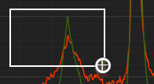 | Click and hold the left mouse button, slide from left to right, and a white magnifying frame will automatically appear along with the sliding area. After releasing the mouse, the frame selection area will be enlarged to full screen display.
9 Curve recovery | 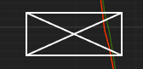 | Click and hold the left button of the mouse, slide from right to left, and a white envelope frame will automatically appear along with the sliding area. After releasing the mouse, all spectral curves will return to their original display state.

Spectrum page
Switch, add or delete spectrum pages.
1 Switch pages |  | Click the page name to switch the view of the spectrum.
2 add page |  | Add blank spectrum pages, page numbers are automatically generated in numerical order .
3 delete page |  | Delete this spectrum page.

Spectral recording
Select and name spectra on the current page of the Spectrum window, including a list of spectrum entries and a spectrum selection button, as shown in Figure 7.1 .
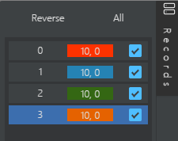
Figure 7.1
Click " Records ", the spectral record entry area will be automatically hidden; click again to restore the display.

Spectral selection
Selected spectrum.
1 check |  | The selected spectral entry is displayed on the current page of the Spectrum window.
2 Reverse election |  | Click the button to deselect the spectrum in the spectrum entry list.
3 select all |  | Click the button to select all spectra in the spectrum entry list. Click again to deselect all.
4 Highlight selected |  | Click an entry, and the entry will be highlighted, which supports subsequent operations such as deletion, smoothing, defluorescence, and background deduction for a single spectrum.

Spectral entry
The list is displayed and named as shown in Figure 7.2 .
1 item name | 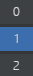 | Each time a new spectrum entry is added, a number is automatically generated in sequence as the name of the entry.
2 entry naming | 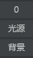 | Click on the entry name to change the spectrum name; click any area outside the box (except the spectral curve area) again, and the setting takes effect.
3 entry color | 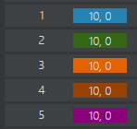 | In the normal detection mode, the color of the spectrum entry is automatically generated by blue-green-orange-coffee-purple, which is consistent with the color of the spectrum curve.  In the extended detection mode, the color of the spectrum entry is automatically generated by purple-blue-green-orange-coffee, which is consistent with the color of the spectrum curve.
4 Working Spectrum |  | The spectral entry with the name "0" is the current working spectral entry and cannot be renamed or deleted.
5 entry parameter |  | The 2 parameters of the spectrum (integration time, laser power) are displayed on the color bar of the spectrum entry.

contact us
Users can contact SIMTRUM in the following ways to inquire about software operation methods and obtain software upgrade services.
support hotline | 65 6996 0391
Consultation mailbox | info@simtrum.com
official website | www.simtrum.com

